Introduction
In an effort to provide the industry with the most accurate performance flow data of a roof drain, Zurn Industries has endeavored upon an initiative to provide complete and reliable performance results of its main roof drain products.

About the Test Method and Data Collection
The data contained within this document is compiled from flow tests that were conducted within a laboratory setting. Outside variables, such as wind, atmospheric temperature, intermittent change in rainfall intensity, and physical obstacles that alter the deliverance of water to the drain, have been excluded from the test procedure to provide reliably consistent data. Each roof drain is tested upon a test stand that is constructed and operated within compliance of ASME Standard A112.6.9. Three outlet piping configurations have been selected and utilized to deliver flow performance graphs and charts that provide the plumbing engineer with a selection of data that best fits the application. Those pipe configurations consist of the following:
- One-foot vertical drop by five-foot horizontal length with ¼ bend elbow
- Two-foot vertical drop by five-foot horizontal length with ¼ bend elbow
- Four-foot vertical drop

Disclaimer of the data contained within this document
Results obtained from application of flow measurement procedures indicate a flow rate achieved under laboratory conditions, utilizing a test apparatus in accordance with ASME A112.6.9, and one of three alternative discharge configurations. The test stand and procedure reduce the effects of uncontrollable variables that exist on a roof setting. All added elements of drainage design will increase or decrease flow rates obtained in testing. Variables such as wind, vortices, debris, roof design, roof obstructions, roof slope, micro-bursts, etc. can significantly change flow rate over what is reported here. Designers are advised to consider these and other possible variables in roof drainage system design.

Step-By-Step Sizing of Zurn Z100 Roof Drains (Flat Roof Scenario)
Note: The below steps apply to a flat (non-sloped) roof scenario. Where a sloped roof scenario exists, the designer must determine how the sloped surfaces leading to the drain will affect maximum ponding depth around the drain.
Step 1 Calculate Total Roof Area (Sq. Ft.)
Example: Roof dimensions are 450 ft. x 800 ft.
Area = 450 x 800 = 360,000 Sq. Ft.

Step 2 Determine Rainfall Rate for Applicable Site Location (inches)
Identify the appropriate Storm Drainage Precipitation Rate Map that is required to be used by Code within the site area. Reference the map to obtain a rainfall rate with a known storm duration.
Example: The map below is taken from the 2018 International Plumbing Code (IPC) and is for reference example only. The map shows a 100-year, 1-Hour Rainfall event. The site location for this example is in Jacksonville, FL, which would yield an hourly rainfall rate of 4.25 inches.

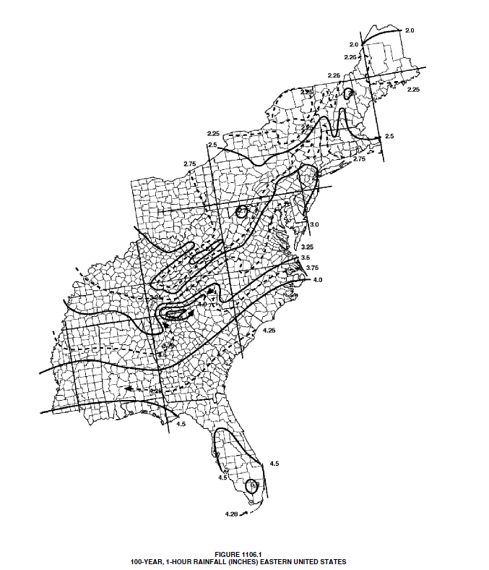
© 2018, International Code Council, Inc., Washington, D.C. Reproduced with permission. All rights reserved.

Step 3 Determine the Total Rainfall Volume on the Roof (Cu. Ft.)
Multiply the Total Roof Area from Step 1 (Sq. Ft.) by the Rainfall Rate from Step 2 (Ft.) to obtain a Total Rainfall Volume.
Example: 360,000 Sq. Ft. x (4.25 in./hr x (1 Ft. / 12 in.) = 127,500 Cu. Ft./hr

Step 4 Convert the Total Rainfall Volume on the Roof to Gallons
Multiply the Total Roof Volume from Step 1 (Cu. Ft.) by (7.481 Gals / Cu. Ft.) to obtain a Total Rainfall Volume (Gals.).
Example: 127,500 Cu. Ft./hr x (7.481 Gals. / Cu. Ft.) = 953,828 Gals./hr

Step 5 Determine the Total Flow Rate off of the Roof Required (GPM)
Divide the Total Volume on the Roof from Step 4 (Gals./hr) by (60 mins.) to obtain a Total Flow Rate required (GPM).
Example: 953,828 (Gals./hr) / 60 mins. = 15,897 GPM

Step 6 Select the Leader Size that is preferred for the Roof Drain Outlet
This input is defined by the plumbing engineer to complete the drain sizing exercise. The results may show that the selected size does not yield a preferred system design, and this input will need revised.
Example: For this exercise, a 4-in. Leader Size is selected.

Step 7 Identify a Maximum Ponding Depth Allowed on the Roof Structure
Variables, such as slope of the roof surface, design of the structural roof components, and maximum load rating of the roof, can drive the maximum ponding value. The plumbing engineer is advised to consult local plumbing codes and work closely with the architect / structural engineer to agree upon a maximum ponding depth. For the following example, a flat-roof design is assumed. The designer must determine real maximum achievable ponding depths that can exist, based upon roof surface slope to the drain, rainfall intensity, storm duration, micro-bursts, and flow capabilities of the roof drain.
Example: For this exercise, a 2.5-in. maximum ponding depth is selected.

Step 8 Select One of the Three Tested Piping Configurations that Best Matches to the Site Scenario
As mentioned above, the drain has been performance tested under three different piping configurations. Select one that best fits the actual construction scenario.
Example: For this exercise, a two-foot vertical drop by five-foot horizontal length with ¼ bend elbow is selected.

Step 9 Cross Reference the Performance Flow Graph with the Selected Leader Size, Pipe Configuration, and Maximum Ponding Depth to Obtain a Drain Flow Rate
Using the appropriate graph and pipe configuration, draw a vertical line on the graph at the ponding depth value until the line intersects the appropriate curve. Then draw a horizontal line from the intersection point to obtain the drain flow rate value at the selected input parameters.
Example: The flow curve below shows that a 4-in. outlet drain with a 2-ft. x 5-ft. pipe configuration, and a ponding depth of 2.5 inches will yield a drain flow of 285 GPM.

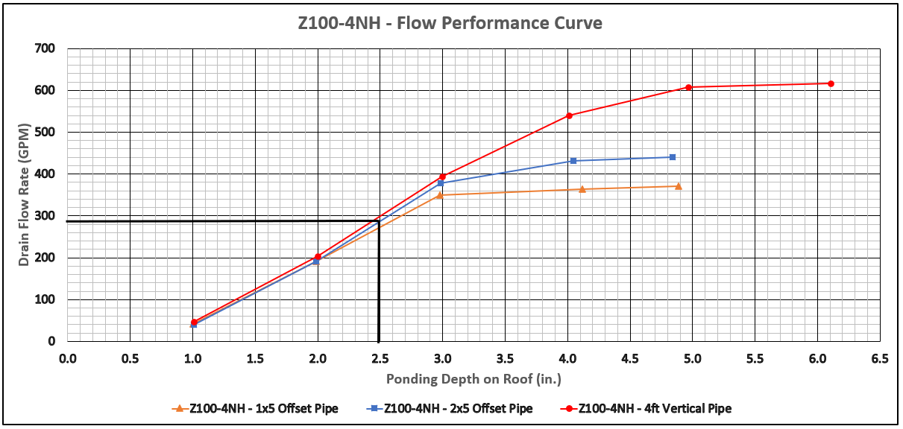

Step 10 Determine the Number of Roof Drains Required
Divide the Total Flow Rate (GPM) off of the Roof from Step 5 by the Drain Flow Rate (GPM) from Step 9 to determine the number of drains required for the exercise (Round up to a whole number).
Example: 15,897 GPM / 285 GPM = 55.77 Drains …… 56 Drains Total

Step 11 Determine the Roof Area that Each Drain Can Cover
Divide the Total Roof Area (Sq. Ft.) from Step 1 by the Number of Roof Drains Required from Step 10 to determine the maximum roof section area that each drain can accommodate.
Example: 360,000 Sq. Ft. / 56 Drains = 6,429 Sq. Ft. per Drain

Step 12 Review Summary
Results of the sizing exercise will change, dependent upon the inputs used to derive the results. The scenario should be evaluated to ensure all applicable codes and recommended sizing guidelines are followed and that results fall within allowable code requirements.
Zurn Z100-2NH Roof Drain Flow Data
The performance data provided below is specific to a standard Zurn Z100 - 15” diameter main roof drain with low silhouette polydome and 2” No-hub outlet. Any variations to the drain configuration may influence and yield different performance data. For additional information on other Zurn drain configurations, please contact Zurn Customer Service.
Results obtained from application of flow measurement procedures indicate a flow rate achieved under laboratory conditions, utilizing a test apparatus in accordance with ASME A112.6.9, and one of three alternative discharge configurations. The test stand and procedure reduce the effects of uncontrollable variables that exist on a roof setting. All added elements of drainage design will increase or decrease flow rates obtained in testing. Variables such as wind, vortices, debris, roof design, roof obstructions, roof slope, micro-bursts, etc. can significantly change flow rate over what is reported here. Designers are advised to consider these and other possible variables in roof drainage system design.

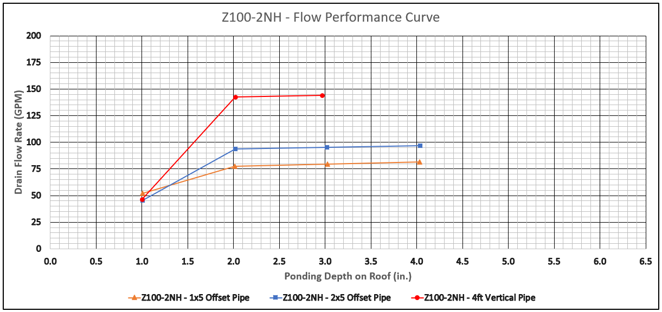

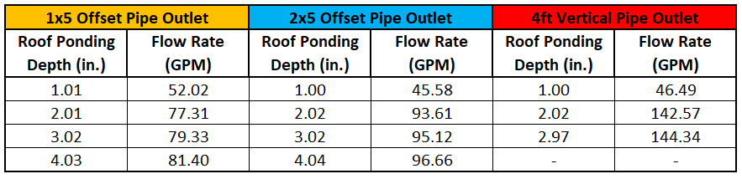

Zurn Z100-3NH Roof Drain Flow Data
The performance data provided below is specific to a standard Zurn Z100 - 15” diameter main roof drain with low silhouette polydome and 3” No-hub outlet. Any variations to the drain configuration may influence and yield different performance data. For additional information on other Zurn drain configurations, please contact Zurn Customer Service.
Results obtained from application of flow measurement procedures indicate a flow rate achieved under laboratory conditions, utilizing a test apparatus in accordance with ASME A112.6.9, and one of three alternative discharge configurations. The test stand and procedure reduce the effects of uncontrollable variables that exist on a roof setting. All added elements of drainage design will increase or decrease flow rates obtained in testing. Variables such as wind, vortices, debris, roof design, roof obstructions, roof slope, micro-bursts, etc. can significantly change flow rate over what is reported here. Designers are advised to consider these and other possible variables in roof drainage system design.

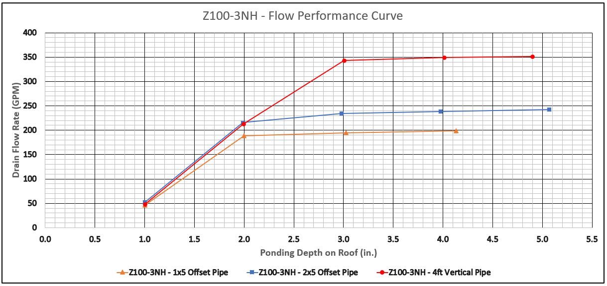

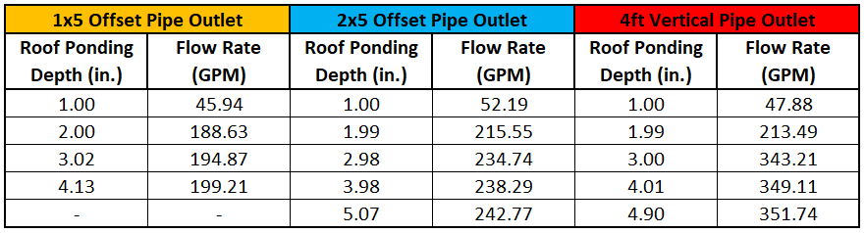
Zurn Z100-4NH Roof Drain Flow Data
The performance data provided below is specific to a standard Zurn Z100 - 15” diameter main roof drain with low silhouette polydome and 4” No-hub outlet. Any variations to the drain configuration may influence and yield different performance data. For additional information on other Zurn drain configurations, please contact Zurn Customer Service.
Results obtained from application of flow measurement procedures indicate a flow rate achieved under laboratory conditions, utilizing a test apparatus in accordance with ASME A112.6.9, and one of three alternative discharge configurations. The test stand and procedure reduce the effects of uncontrollable variables that exist on a roof setting. All added elements of drainage design will increase or decrease flow rates obtained in testing. Variables such as wind, vortices, debris, roof design, roof obstructions, roof slope, micro-bursts, etc. can significantly change flow rate over what is reported here. Designers are advised to consider these and other possible variables in roof drainage system design.

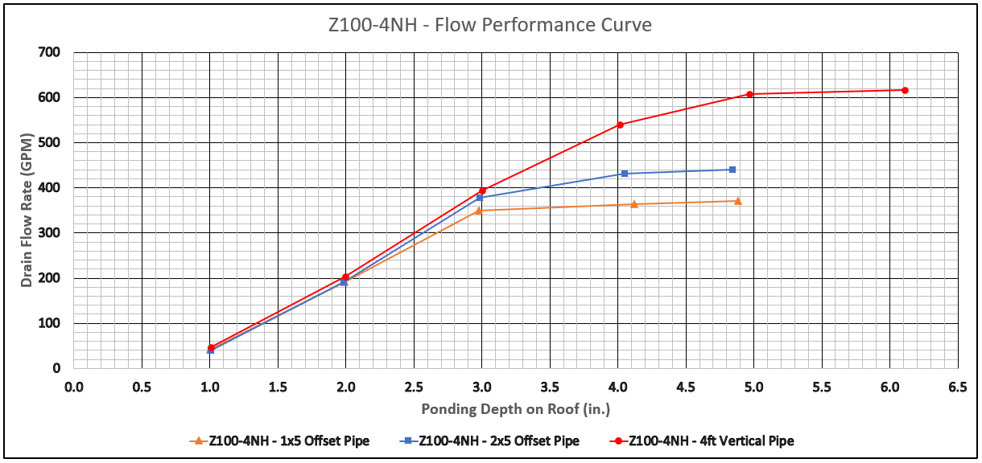

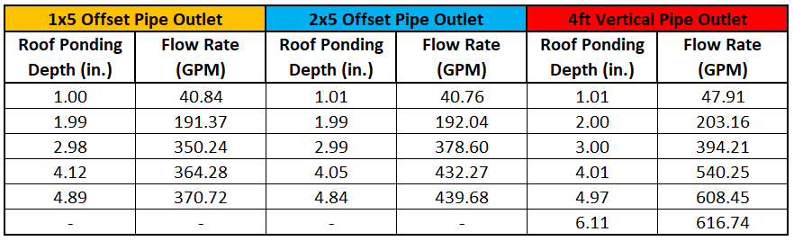
Zurn Z100-6NH Roof Drain Flow Data
The performance data provided below is specific to a standard Zurn Z100 - 15” diameter main roof drain with low silhouette polydome and 6” No-hub outlet. Any variations to the drain configuration may influence and yield different performance data. For additional information on other Zurn drain configurations, please contact Zurn Customer Service.
Results obtained from application of flow measurement procedures indicate a flow rate achieved under laboratory conditions, utilizing a test apparatus in accordance with ASME A112.6.9, and one of three alternative discharge configurations. The test stand and procedure reduce the effects of uncontrollable variables that exist on a roof setting. All added elements of drainage design will increase or decrease flow rates obtained in testing. Variables such as wind, vortices, debris, roof design, roof obstructions, roof slope, micro-bursts, etc. can significantly change flow rate over what is reported here. Designers are advised to consider these and other possible variables in roof drainage system design.

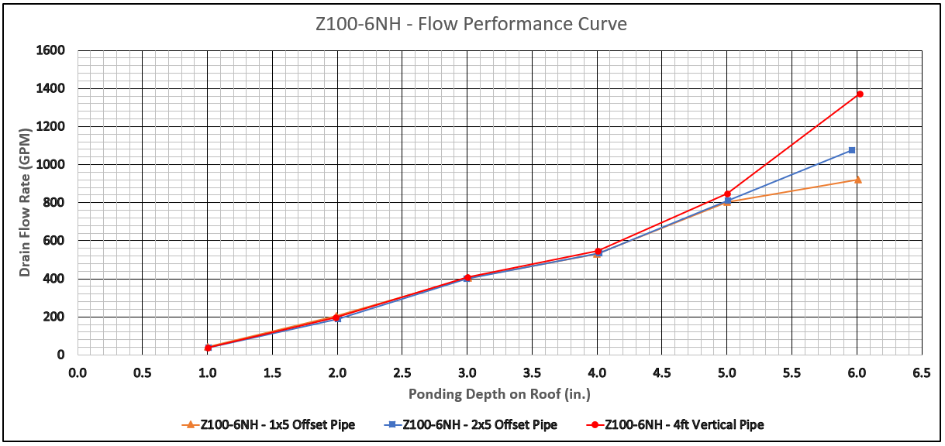

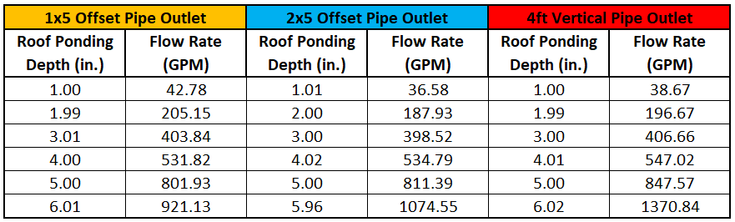
Zurn Z100-8NH Roof Drain Flow Data
The performance data provided below is specific to a standard Zurn Z100 - 15” diameter main roof drain with low silhouette polydome and 8” No-hub outlet. Any variations to the drain configuration may influence and yield different performance data. For additional information on other Zurn drain configurations, please contact Zurn Customer Service.
Results obtained from application of flow measurement procedures indicate a flow rate achieved under laboratory conditions, utilizing a test apparatus in accordance with ASME A112.6.9, and one of three alternative discharge configurations. The test stand and procedure reduce the effects of uncontrollable variables that exist on a roof setting. All added elements of drainage design will increase or decrease flow rates obtained in testing. Variables such as wind, vortices, debris, roof design, roof obstructions, roof slope, micro-bursts, etc. can significantly change flow rate over what is reported here. Designers are advised to consider these and other possible variables in roof drainage system design.

